## **Group Project Document – Part 3**

## **Grocery Store Chain Database**

* **Project Part 02**
* **Team Number 02**
* **Team Members:**
  + Fuad Hassan
  + Omar Shakir
  + Tony Siu
  + Heron Ziegel
* **Database System Name:** **Grocery Store Chain Database**

**Part 1:**

## Requirements:

* Each **Employee** has a EmployeeID (unique), a FirstName and a LastName.
* Each **Customer** has a CustomerID (unique), a FirstName and a LastName.
* Each **Item** has a ItemID (unique), Price, Description.
* Each **Order** has a unique OrderID, a PurchaseDate, and may have a TimeCompleted or might not be completed yet. Each Order also has a TotalPrice, which is calculated based on the price of every Item in that Order.
* Each **Store** has a unique StoreID, and an Address made up of a Street, City, State and ZipCode.
* Each Employee works at exactly one Store, but each Store has at least one and can have many Employees.
* Each Order contains multiple Items and at least one, and each Item can be in multiple Orders or none.
* Each Employee processes zero or more orders. And Each Order much be processed by one Employee.
* Each Customer can have multiple Orders but doesn’t need to have any Orders. Each Order belongs to exactly one Customer.
* Each Customer can visit many stores and must visit at least one. Each Store can have multiple customers or at least one.
* Each Order is created at exactly one Store, and each Store has anywhere from no Orders to many.

## **ER diagram –** : Grocery Store Chain Database

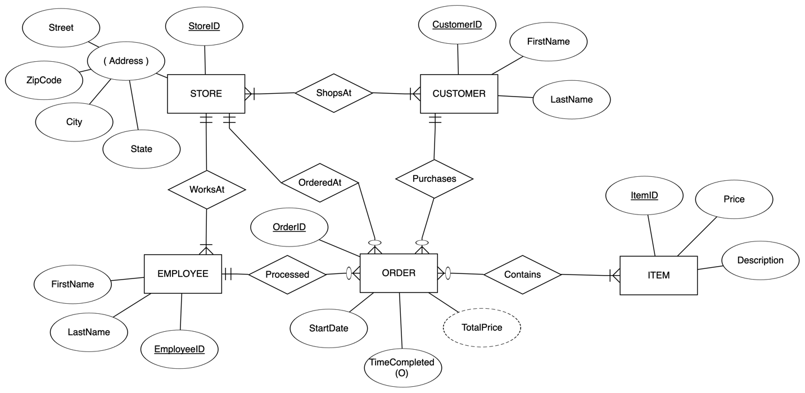

**Relational schema diagram** -: Grocery Store Chain Database

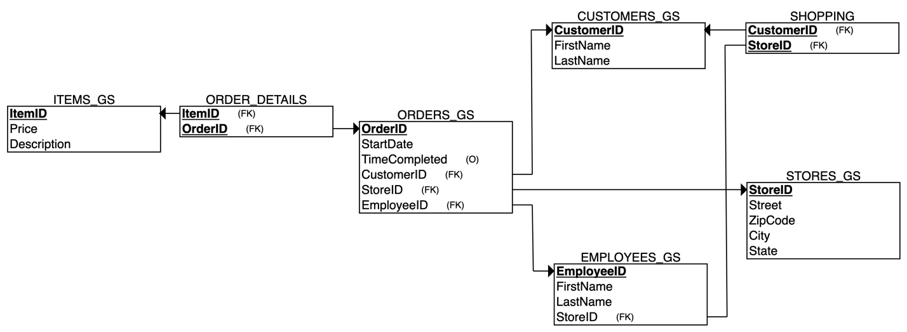

**SQL** -: Grocery Store Chain Database

-- Dropping all table before inserting

DROP TABLE ORDERS_DETAILS_GS;

DROP TABLE ORDERS_GS;

DROP TABLE ITEMS_GS;

DROP TABLE EMPLOYEES_GS;

DROP TABLE SHOPPING_GS;

DROP TABLE STORES_GS;

DROP TABLE CUSTOMERS_GS;

-- STORES_GS

CREATE TABLE STORES_GS (

StoreID INT NOT NULL,

Street VARCHAR(50) NOT NULL,

ZipCode INT NOT NULL,

City VARCHAR(50) NOT NULL,

State CHAR(2) NOT NULL,

PRIMARY KEY (StoreID)

);

insert into STORES_GS (StoreID, Street, ZipCode, City, State)

values (1, 'Maple', '20057', 'Washington', 'DC');

insert into STORES_GS (StoreID, Street, ZipCode, City, State)

values (2, 'Marquette', '66286', 'Shawnee Mission', 'KS');

insert into STORES_GS (StoreID, Street, ZipCode, City, State)

values (3, 'Forest', '45403', 'Dayton', 'OH');

-- EMPLOYEES_GS

CREATE TABLE EMPLOYEES_GS (

EmployeeID INT NOT NULL,

FirstName VARCHAR2(50) NOT NULL,

LastName VARCHAR2(50) NOT NULL,

StoreID INT NOT NULL,

PRIMARY KEY (EmployeeID),

FOREIGN KEY (StoreID) REFERENCES STORES_GS(StoreID)

);

insert into EMPLOYEES_GS (EmployeeID, FirstName, LastName, StoreID)

values (1, 'Pascale', 'Woodard', 2);

insert into EMPLOYEES_GS (EmployeeID, FirstName, LastName, StoreID)

values (2, 'Garret', 'Blunsum', 2);

insert into EMPLOYEES_GS (EmployeeID, FirstName, LastName, StoreID)

values (3, 'Salomi', 'Barok', 1);

insert into EMPLOYEES_GS (EmployeeID, FirstName, LastName, StoreID)

values (4, 'Etan', 'Abad', 2);

insert into EMPLOYEES_GS (EmployeeID, FirstName, LastName, StoreID)

values (5, 'Bernarr', 'Davidescu', 3);

insert into EMPLOYEES_GS (EmployeeID, FirstName, LastName, StoreID)

values (6, 'Maritsa', 'Brittian', 3);

insert into EMPLOYEES_GS (EmployeeID, FirstName, LastName, StoreID)

values (7, 'Meriel', 'Ralling', 3);

insert into EMPLOYEES_GS (EmployeeID, FirstName, LastName, StoreID)

values (8, 'Ruddy', 'Clay', 1);

insert into EMPLOYEES_GS (EmployeeID, FirstName, LastName, StoreID)

values (9, 'Jyoti', 'Simanek', 3);

insert into EMPLOYEES_GS (EmployeeID, FirstName, LastName, StoreID)

values (10, 'Althea', 'Housecroft', 1);

-- CUSTOMERS_GS

CREATE TABLE CUSTOMERS_GS (

CustomerID INT NOT NULL,

FirstName VARCHAR(50) NOT NULL,

LastName VARCHAR(50) NOT NULL,

PRIMARY KEY (CustomerID)

);

insert into CUSTOMERS_GS (CustomerID, FirstName, LastName)

values (1, 'Twila', 'O''Sherrin');

insert into CUSTOMERS_GS (CustomerID, FirstName, LastName)

values (2, 'Natka', 'McGaughay');

insert into CUSTOMERS_GS (CustomerID, FirstName, LastName)

values (3, 'Boot', 'Cino');

insert into CUSTOMERS_GS (CustomerID, FirstName, LastName)

values (4, 'Sharline', 'Creagh');

insert into CUSTOMERS_GS (CustomerID, FirstName, LastName)

values (5, 'Astrid', 'Mcall');

insert into CUSTOMERS_GS (CustomerID, FirstName, LastName)

values (6, 'Gilberte', 'Nairn');

insert into CUSTOMERS_GS (CustomerID, FirstName, LastName)

values (7, 'Kirk', 'Maffini');

insert into CUSTOMERS_GS (CustomerID, FirstName, LastName)

values (8, 'Demetrius', 'Prigg');

insert into CUSTOMERS_GS (CustomerID, FirstName, LastName)

values (9, 'Dulsea', 'Latta');

insert into CUSTOMERS_GS (CustomerID, FirstName, LastName)

values (10, 'Penni', 'Harper');

insert into CUSTOMERS_GS (CustomerID, FirstName, LastName)

values (11, 'Bellina', 'Koenen');

insert into CUSTOMERS_GS (CustomerID, FirstName, LastName)

values (12, 'Catlee', 'Backman');

insert into CUSTOMERS_GS (CustomerID, FirstName, LastName)

values (13, 'Terra', 'St Ledger');

insert into CUSTOMERS_GS (CustomerID, FirstName, LastName)

values (14, 'Yoshiko', 'Briston');

insert into CUSTOMERS_GS (CustomerID, FirstName, LastName)

values (15, 'Caresa', 'Gisbey');

insert into CUSTOMERS_GS (CustomerID, FirstName, LastName)

values (16, 'Maurizio', 'Buffham');

insert into CUSTOMERS_GS (CustomerID, FirstName, LastName)

values (17, 'Cos', 'Basire');

insert into CUSTOMERS_GS (CustomerID, FirstName, LastName)

values (18, 'Irwin', 'Beaton');

insert into CUSTOMERS_GS (CustomerID, FirstName, LastName)

values (19, 'Nelli', 'Morcomb');

insert into CUSTOMERS_GS (CustomerID, FirstName, LastName)

values (20, 'Fallon', 'Gomby');

-- SHOPPING_GS

CREATE TABLE SHOPPING_GS (

CustomerID INT NOT NULL,

StoreID INT NOT NULL,

PRIMARY KEY (CustomerID, StoreID),

FOREIGN KEY (CustomerID) REFERENCES CUSTOMERS_GS(CustomerID),

FOREIGN KEY (StoreID) REFERENCES STORES_GS(StoreID)

);

insert into SHOPPING_GS (CustomerID, StoreID)

values (1, 2);

insert into SHOPPING_GS (CustomerID, StoreID)

values (2, 1);

insert into SHOPPING_GS (CustomerID, StoreID)

values (3, 3);

insert into SHOPPING_GS (CustomerID, StoreID)

values (4, 3);

insert into SHOPPING_GS (CustomerID, StoreID)

values (5, 3);

insert into SHOPPING_GS (CustomerID, StoreID)

values (6, 1);

insert into SHOPPING_GS (CustomerID, StoreID)

values (7, 1);

insert into SHOPPING_GS (CustomerID, StoreID)

values (8, 2);

insert into SHOPPING_GS (CustomerID, StoreID)

values (9, 2);

insert into SHOPPING_GS (CustomerID, StoreID)

values (10, 1);

insert into SHOPPING_GS (CustomerID, StoreID)

values (11, 1);

insert into SHOPPING_GS (CustomerID, StoreID)

values (12, 2);

insert into SHOPPING_GS (CustomerID, StoreID)

values (13, 2);

insert into SHOPPING_GS (CustomerID, StoreID)

values (14, 2);

insert into SHOPPING_GS (CustomerID, StoreID)

values (15, 3);

insert into SHOPPING_GS (CustomerID, StoreID)

values (16, 2);

insert into SHOPPING_GS (CustomerID, StoreID)

values (17, 2);

insert into SHOPPING_GS (CustomerID, StoreID)

values (18, 2);

insert into SHOPPING_GS (CustomerID, StoreID)

values (19, 1);

insert into SHOPPING_GS (CustomerID, StoreID)

values (20, 1);

-- ITEMS_GS

CREATE TABLE ITEMS_GS (

ItemID INT NOT NULL,

Price DECIMAL(10, 2) NOT NULL,

Description VARCHAR(255),

PRIMARY KEY (ItemID)

);

insert into ITEMS_GS (ItemID, Price, Description)

values (1, 45.35, 'Sambuca - Opal Nera');

insert into ITEMS_GS (ItemID, Price, Description)

values (2, 5.56, 'Lotus Root');

insert into ITEMS_GS (ItemID, Price, Description)

values (3, 8.95, 'Sauce - Soya, Light');

insert into ITEMS_GS (ItemID, Price, Description)

values (4, 1.61, 'Bread - Roll, Canadian Dinner');

insert into ITEMS_GS (ItemID, Price, Description)

values (5, 30.06, 'Melon - Honey Dew');

insert into ITEMS_GS (ItemID, Price, Description)

values (6, 9.54, 'Dates');

insert into ITEMS_GS (ItemID, Price, Description)

values (7, 9.91, 'Steampan Lid');

insert into ITEMS_GS (ItemID, Price, Description)

values (8, 29.24, 'Langers - Cranberry Cocktail');

insert into ITEMS_GS (ItemID, Price, Description)

values (9, 29.16, 'Asparagus - Green, Fresh');

insert into ITEMS_GS (ItemID, Price, Description)

values (10, 30.0, 'Pasta - Spaghetti, Dry');

insert into ITEMS_GS (ItemID, Price, Description)

values (11, 29.56, 'Cornish Hen');

insert into ITEMS_GS (ItemID, Price, Description)

values (12, 1.22, 'Ostrich - Prime Cut');

insert into ITEMS_GS (ItemID, Price, Description)

values (13, 8.81, 'Tart - Lemon');

insert into ITEMS_GS (ItemID, Price, Description)

values (14, 14.75, 'Pasta - Lasagna Noodle, Frozen');

insert into ITEMS_GS (ItemID, Price, Description)

values (15, 7.76, 'Anisette - Mcguiness');

insert into ITEMS_GS (ItemID, Price, Description)

values (16, 17.37, 'Venison - Striploin');

insert into ITEMS_GS (ItemID, Price, Description)

values (17, 7.57, 'Juice - V8, Tomato');

insert into ITEMS_GS (ItemID, Price, Description)

values (18, 37.03, 'Ice Cream - Super Sandwich');

insert into ITEMS_GS (ItemID, Price, Description)

values (19, 3.26, 'Ocean Spray - Ruby Red');

insert into ITEMS_GS (ItemID, Price, Description)

values (20, 30.65, 'Cheese - Goat');

-- ORDERS_GS

CREATE TABLE ORDERS_GS (

OrderID INT NOT NULL,

StartDate DATE NOT NULL,

TimeCompleted DATE NULL,

CustomerID INT NOT NULL,

StoreID INT NOT NULL,

EmployeeID INT NOT NULL,

PRIMARY KEY (OrderID),

FOREIGN KEY (CustomerID) REFERENCES CUSTOMERS_GS(CustomerID),

FOREIGN KEY (StoreID) REFERENCES STORES_GS(StoreID),

FOREIGN KEY (EmployeeID) REFERENCES EMPLOYEES_GS(EmployeeID)

);

insert into ORDERS_GS (

OrderID,

StartDate,

TimeCompleted,

CustomerID,

StoreID,

EmployeeID

)

values (

1,

TO_DATE('2024-04-20', 'YYYY-MM-DD'),

NULL,

1,

1,

2

);

insert into ORDERS_GS (

OrderID,

StartDate,

TimeCompleted,

CustomerID,

StoreID,

EmployeeID

)

values (

2,

TO_DATE('2024-04-20', 'YYYY-MM-DD'),

NULL,

2,

2,

1

);

insert into ORDERS_GS (

OrderID,

StartDate,

TimeCompleted,

CustomerID,

StoreID,

EmployeeID

)

values (

3,

TO_DATE('2024-04-21', 'YYYY-MM-DD'),

TO_DATE('15:30:00', 'HH24:MI:SS'),

3,

3,

5

);

insert into ORDERS_GS (

OrderID,

StartDate,

TimeCompleted,

CustomerID,

StoreID,

EmployeeID

)

values (

4,

TO_DATE('2024-04-21', 'YYYY-MM-DD'),

TO_DATE('16:30:00', 'HH24:MI:SS'),

4,

3,

9

);

insert into ORDERS_GS (

OrderID,

StartDate,

TimeCompleted,

CustomerID,

StoreID,

EmployeeID

)

values (

5,

TO_DATE('2024-04-21', 'YYYY-MM-DD'),

TO_DATE('16:30:00', 'HH24:MI:SS'),

5,

3,

5

);

insert into ORDERS_GS (

OrderID,

StartDate,

TimeCompleted,

CustomerID,

StoreID,

EmployeeID

)

values (

6,

TO_DATE('2024-04-21', 'YYYY-MM-DD'),

TO_DATE('16:35:00', 'HH24:MI:SS'),

6,

1,

10

);

insert into ORDERS_GS (

OrderID,

StartDate,

TimeCompleted,

CustomerID,

StoreID,

EmployeeID

)

values (

7,

TO_DATE('2024-04-21', 'YYYY-MM-DD'),

TO_DATE('16:35:00', 'HH24:MI:SS'),

7,

1,

8

);

insert into ORDERS_GS (

OrderID,

StartDate,

TimeCompleted,

CustomerID,

StoreID,

EmployeeID

)

values (

8,

TO_DATE('2024-04-21', 'YYYY-MM-DD'),

TO_DATE('16:40:00', 'HH24:MI:SS'),

8,

2,

2

);

insert into ORDERS_GS (

OrderID,

StartDate,

TimeCompleted,

CustomerID,

StoreID,

EmployeeID

)

values (

9,

TO_DATE('2024-04-21', 'YYYY-MM-DD'),

TO_DATE('17:30:00', 'HH24:MI:SS'),

9,

2,

3

);

insert into ORDERS_GS (

OrderID,

StartDate,

TimeCompleted,

CustomerID,

StoreID,

EmployeeID

)

values (

10,

TO_DATE('2024-04-21', 'YYYY-MM-DD'),

TO_DATE('10:30:00', 'HH24:MI:SS'),

10,

1,

3

);

-- ORDERS_DETAILS_GS

CREATE TABLE ORDERS_DETAILS_GS (

ItemID INT NOT NULL,

OrderID INT NOT NULL,

PRIMARY KEY (ItemID, OrderID),

FOREIGN KEY (ItemID) REFERENCES ITEMS_GS(ItemID),

FOREIGN KEY (OrderID) REFERENCES ORDERS_GS(OrderID)

);

insert into ORDERS_DETAILS_GS (ItemID, OrderID)

values (1, 1);

insert into ORDERS_DETAILS_GS (ItemID, OrderID)

values (2, 2);

insert into ORDERS_DETAILS_GS (ItemID, OrderID)

values (3, 3);

insert into ORDERS_DETAILS_GS (ItemID, OrderID)

values (4, 4);

insert into ORDERS_DETAILS_GS (ItemID, OrderID)

values (5, 5);

insert into ORDERS_DETAILS_GS (ItemID, OrderID)

values (1, 6);

insert into ORDERS_DETAILS_GS (ItemID, OrderID)

values (1, 2);

insert into ORDERS_DETAILS_GS (ItemID, OrderID)

values (1, 3);

insert into ORDERS_DETAILS_GS (ItemID, OrderID)

values (5, 4);

insert into ORDERS_DETAILS_GS (ItemID, OrderID)

values (1, 5);

insert into ORDERS_DETAILS_GS (ItemID, OrderID)

values (3, 8);

insert into ORDERS_DETAILS_GS (ItemID, OrderID)

values (2, 9);

insert into ORDERS_DETAILS_GS (ItemID, OrderID)

values (1, 10);

insert into ORDERS_DETAILS_GS (ItemID, OrderID)

values (2, 6);

insert into ORDERS_DETAILS_GS (ItemID, OrderID)

values (5, 6);

insert into ORDERS_DETAILS_GS (ItemID, OrderID)

values (6, 6);

insert into ORDERS_DETAILS_GS (ItemID, OrderID)

values (7, 6);

insert into ORDERS_DETAILS_GS (ItemID, OrderID)

values (8, 6);

insert into ORDERS_DETAILS_GS (ItemID, OrderID)

values (10, 7);

insert into ORDERS_DETAILS_GS (ItemID, OrderID)

values (5, 7);

insert into ORDERS_DETAILS_GS (ItemID, OrderID)

values (6, 7);

insert into ORDERS_DETAILS_GS (ItemID, OrderID)

values (7, 7);

insert into ORDERS_DETAILS_GS (ItemID, OrderID)

values (8, 7);

insert into ORDERS_DETAILS_GS (ItemID, OrderID)

values (9, 8);

insert into ORDERS_DETAILS_GS (ItemID, OrderID)

values (5, 8);

insert into ORDERS_DETAILS_GS (ItemID, OrderID)

values (6, 8);

insert into ORDERS_DETAILS_GS (ItemID, OrderID)

values (7, 8);

insert into ORDERS_DETAILS_GS (ItemID, OrderID)

values (8, 8);

insert into ORDERS_DETAILS_GS (ItemID, OrderID)

values (3, 9);

insert into ORDERS_DETAILS_GS (ItemID, OrderID)

values (5, 9);

insert into ORDERS_DETAILS_GS (ItemID, OrderID)

values (6, 9);

insert into ORDERS_DETAILS_GS (ItemID, OrderID)

values (7, 9);

insert into ORDERS_DETAILS_GS (ItemID, OrderID)

values (8, 9);

insert into ORDERS_DETAILS_GS (ItemID, OrderID)

values (9, 10);

insert into ORDERS_DETAILS_GS (ItemID, OrderID)

values (5, 10);

insert into ORDERS_DETAILS_GS (ItemID, OrderID)

values (6, 10);

insert into ORDERS_DETAILS_GS (ItemID, OrderID)

values (7, 10);

insert into ORDERS_DETAILS_GS (ItemID, OrderID)

values (8, 10);

**Example q**

-- 1. gets the total cost per order

SELECT ORDERS_GS.CustomerID,

ORDERS_GS.OrderID,

CUSTOMERS_GS.FirstName,

CUSTOMERS_GS.LastName,

SUM(ITEMS_GS.Price) AS TotalItemCost

FROM ORDERS_GS

JOIN CUSTOMERS_GS ON ORDERS_GS.CustomerID = CUSTOMERS_GS.CustomerID

JOIN ORDERS_DETAILS_GS ON ORDERS_GS.OrderID = ORDERS_DETAILS_GS.OrderID

JOIN ITEMS_GS ON ORDERS_DETAILS_GS.ItemID = ITEMS_GS.ItemID

GROUP BY ORDERS_GS.CustomerID,

ORDERS_GS.OrderID,

CUSTOMERS_GS.FirstName,

CUSTOMERS_GS.LastName;

-- 2. Shows the Order and its start and end time

SELECT o.orderid,

o.startdate,

o.TIMECOMPLETED

from ORDERS_GS o

inner join CUSTOMERS_GS c on o.CustomerID = c.CustomerID;

**Tasks Distribution** -: Grocery Store Chain Database

|  |  |
| --- | --- |
| Requirement | Heron, and 3 of us reviewed and edited |
| ERD | Heron, Fuad, Tony, Omar |
| Schema | We all did it together |
| SQL | Fuad, Omar, Tony |
| Summation and writing | Fuad |